91906 - Testing Document

**Unit Testing**

|  |  |  |  |  |  |  |
| --- | --- | --- | --- | --- | --- | --- |
| NAME Function/ Feature | | | | | | |
| Date | What is being tested | Test Type | Test Value | Expected Result | Actual Result | How it was fixed |
|  | Invalid/Boundary/Expected |  |  | . |  |  |
| 23/07/25 | The “Knight” player sprite loads properly | Expected |  | The player sprite appears clearly as a knight at the start of the game. |  | N/A |
| 23/07/25 | The tiled map is imported and loads properly | Expected |  | The Tiled Map loads and can be seen easily. |  | N/A |
| 23/07/25 | Spike killing the player when it makes contact | Expected |  | The player, after touching or landing on the spike will immediately be reset to the start of the level | I was reset after making contact: | N/A |
| 23/07/25 | The climbing terrain functions as intended with the user being able to stop when they want. | Expected |  | The player doesn’t stops climbing when spacebar is released |  | Added an addition on key release effect to spacebar so that the player sprite stops increasing in y when it is released. |
| 23/07/25 | The movement keys function as expected: (next 4 tests) | Expected |  | When right is pressed, the sprite moves right |  | N/A |
|  |  | Expected |  | When left is pressed, the player sprite moves left |  | N/A |
|  |  | Expected |  | When up is pressed, the player jumps |  | N/A |
|  |  | Expected |  | When up and right is pressed the user jumps and moves right. |  | N/A |
| 23/07/25 | When the user falls and contacts the bottom of the map (y=0) they are reset | Boundary |  | When players y <= 0 they instantly get reset to the start. | (y level when reset printed as –2.5 which is due to the check being for when the centre of the sprite makes contact, not their feet.) | Made it so it checks for when the bottom of the sprite contacts the bottom of the level. |
| 23/07/25 | The archers dash functions as intended when moving right. | Expected |  | When space is pressed and the player is moving right or static, they will do a dash to the right |  | N/A |
| 23/07/25 | The archers dash functions as intended when moving left, letting them dash left | Expected |  | When space is pressed and the player is moving left, they will do a dash to the left |  | Made it so the change in x is negative if the players original change in x was negative. |
| 23/07/25 | The wizards float functions as intended, letting them float straight up for a few seconds. | Expected |  | When space is pressed as the wizard, the player will float up for a few seconds. |  | N/A |
| 29/07/25 | The wizard float function floats up but not through walls. | Expected |  | When space is pressed the wizard will float upward until they hit the ceiling and then will be stuck against it for a bit. |  | Got rid of return True at the end which was ensuring its functionality in flying up but was skipping the physics engine and in turn letting them ignore platforms. (Resolved from feedback after play test.) |
| 29/07/25 | Character walking animations (knight, archer, wizard): | Expected |  | Walk cycle advances, facing direction is left and texture changes rapidly |  | N/A |
|  |  | Expected |  | Walk cycle advances, facing direction is Right and texture changes rapidly |  | N/A |
|  |  | Expected |  | Walk cycle advances, facing direction is Right and texture changes rapidly |  | N/A |
|  |  | Expected |  | Walk cycle advances, facing direction is Left and texture changes rapidly |  | N/A |
|  |  | Expected |  | Walk cycle advances, facing direction is Left and texture changes rapidly |  | N/A |
|  |  | Expected |  | Walk cycle advances, facing direction is Right and texture changes rapidly |  | N/A |
| 29/07/25 | The Knights Climbing animation | Expected |  | He should climb up normally with him switching between the two climbing animation states at a reasonable speed. |  | Fixed issue where the animations updated was time based, the climbing animation would continue even when stagnant, making it so the climbing animation would only run while the user was moving upwards. |
| 29/07/25 | The wizards walk cycle advances while he’s floating | Expected |  | Walk Cycle advances still even when wizard is floating for a simple visual design. |  | N/A |
| 29/07/25 | The archers walk cycle advances while he’s dashing |  |  | Walk Cycle advances still even when archer is dashing for a simple visual design. |  | N/A |
| 30/07/25 | A file that isn’t a character sprite is in the same folder | Invalid |  | The file will be skipped and the game will load as normal |  | N/A |
| 30/07/25 | Health Display and Resetting at 0 health tests: | Expected |  | The player takes damage as normal for 3 and 2 hp, simply having it decreased by one. |  | N/A |
| 30/07/25 |  | Boundary |  | The player takes damage, falling to 0 hp and in turn should be reset to the start of the level. |  | Adjusted one thing to boost performance considerably where instead of re-running set up on player death, I just move the player sprite back to the start of the game. |
| 30/07/25 | Grace Period Flicker Animation | Expected |  | There is a flickering animation for 1 second when the player takes damage. |  | N/A |
| 30/07/25 | The player can’t take damage while they are flickering and in the “grace period” | Invalid |  |  |  | N/A |
| 31/07/25 | Enemies appear wherever they are called moving within flexible x and y boundaries and at flexible speeds | Expected |  | Two enemies are seen moving side to side in different areas. |  | N/A |
| 31/07/25 | Damage is taken on contact with an enemy while the player is full HP | Expected |  | A damage is taken when they make contact at full hp |  | N/A |
| 31/07/25 | Damage is taken on contact with an enemy while the player is on 2 hp | Expected |  | A damage is taken when they make contact at full hp |  | N/A |
| 31/07/25 | The player dies and is reset when they contact an enemy on 1 hp | Expected |  | They die and are reset |  | N/A |
| 31/07/25 | Contact with the exit door | Expected |  | The player progresses to level 2 |  | N/A |
| 31/07/25 | The players second level spawn | Expected |  | The player spawns at the “spawn” door on level 2 |  | N/A |
| |  | | --- | | 31/07/25 | | Releasing climb input mid-ascent | Expected |  | Climbing stops immediately |  | N/A |
| 31/07/25 | Started Climbing when not adjacent to climbable walls | Invalid |  | Nothing happens and movement isn’t affected. |  | N/A |
| 31/08/25 | Wizard Fire | Expected |  | Wizards Fire Deals 2 damage to enemies that it makes contacts. |  | There is an issue where wizard fire and knight slash don’t go away even after hitting an enemy, used the same arrow destruction on collision to remove them. |
| 31/08/25 | Knight Slash | Boundary / Expected |  | The enemy takes 3 damage from knight slash, dieing instantly |  | N/A |
| 31/08/25 | Archer Arrow | Expected |  | The enemy takes 1 damage from archer arrow,. |  | N/A |
| 31/08/25 | Enemies Death | Boundary |  | Enemies die and are instantly removed with their HP equals 0 |  | N/A |
| 31/08/25 | Health Bars Displaying Enemy HP | Expected |  | After being hit, the enemies health bar is displayed |  | N/A |
| 1/08/25 | Enemies movement is fully functional horizontally and vertically on levels past 1 | Expected |  | Ghost can be seen moving horizontally and vertically |  | N/A |
| 1/08/25 | All attacks show visually: | Expected |  | Knight slash can be seen for a bit before disappearing |  | N/A |
| 1/08/25 |  | Expected |  | Archer Arrow can be seen and flies until it hits an enemy or wall. |  | N/A |
| 1/08/25 |  | Expected |  | Wizard fire appears on the ground and doesn’t go away for an extended period |  | N/A |
| 1/08/25 | Whether attacks go away when character is switched | Expected |  | The attack will remain even if the character is switched off | Due to the brevity of other attacks, it’s hard to screenshot but they also work. | N/A |
| 1/08/25 | Victory Screen | Expected |  | After all enemies are slain on level 3, the victory screen is shown |  | I moved the victory screen display to the on_draw function and skipped the drawing of all other aspects such that |
| 1/08/25 | Victory Screen | Expected |  | After all enemies are slain on level 3, the victory screen is shown |  | N/A |

**System Testing**

|  |  |  |  |  |  |  |
| --- | --- | --- | --- | --- | --- | --- |
| **Whole Program** | | | | | | |
| Date | What is being tested | Test Type | Test Value | Expected Result | Actual Result | How it was fixed |
| ALL 1/08/2025 | Game window initialization | Valid | Game Run | Window opens with name RPG Platformer |  | N/A |
|  | Player spawn position | Valid | Start of each level player position | Player spawns |  | N/A |
|  | Character switching | Valid | Press 1 2 and 3 | The character switches from archer to wizard to knight | 1:2:  3: | N/A |
|  | Platform Collision | Boundary | Move towards a platform | Player stop and cannot pass through the boundaries of platform blocks. |  | N/A |
|  | Player death and respawn | Valid | 0 Health behaviour | Player respawns at checkpoint on full health |  | N/A |
|  | Camera system during character abilities | Valid | Characters should all be followed by their character even while using abilities | Camera stays centred even during transport abilities. |  | N/A |
|  | Health Between Levels | Valid | Current HP | Health state is regenerated when a new level is beginning |  | N/A |
|  | Attack cooldowns during character switching | Valid | Attack Cooldown | Cooldowns are character-specific, not global |  | N/A |
|  | The player spams jump repeatedly to fly | Invalid | Can_jump and gravity | The player must touch the ground before jumping again. |  | N/A |
|  | The very edge of the spike does damage if the player sprite contacts its tile | Boundary | Danger | The player takes damage as usual |  | N/A |
|  | Rapid movement inputs with character switching (Dash > Float) | Invalid | Spacebar | The player will dash and then fall, unable to jump and in turn unable to float but can switch character mid-dash. |  | N/A |
|  | Rapid movement inputs with character switching (climb > dash) | Valid | Spacebar | The player will climb then dash in whichever direction they were facing preceding to have started climbing |  | N/A |
|  | After the Victory screen the player tries to restart (esc) | Invalid | Escape | The victory screen will remain. |  | N/A |
|  |  |  |  |  |  |  |

|  |  |  |
| --- | --- | --- |
| Name | Feedback | Changes to Make: |
| Luke haung | Very cool game, climb very wonky, I thought spacebar is jump  Classes very cool | Instruction Screen |
| Daigan coldicott | Good mechanics, bad level design, no place to learn how to play, runs smooth and climbing is too finicky | Instruction Screen Make Climbing Smoother |
| Adrik William | Very cool mechanics and runs smoothly. Needs a tutorial for mechanics/characters and probably level difficulty. Overall, good game. | Give the player multiple lives  Instruction Screen |
| Ben Anderson | Good mechanics and it is cool with the different characters and concept I would make it so there are less bugs and slightly smoother movement |  |
| Nikau Falk Andrew Lennoel Alexander | I think that it should be clearer on how the characters work and maybe hints on how to use the mechanics. The characters could also change the look of their direction theyre moving/looking in. | Instruction Screen and Sprites flipping in direction they face while moving |

Changes off all first feedback:

Instruction Screen:

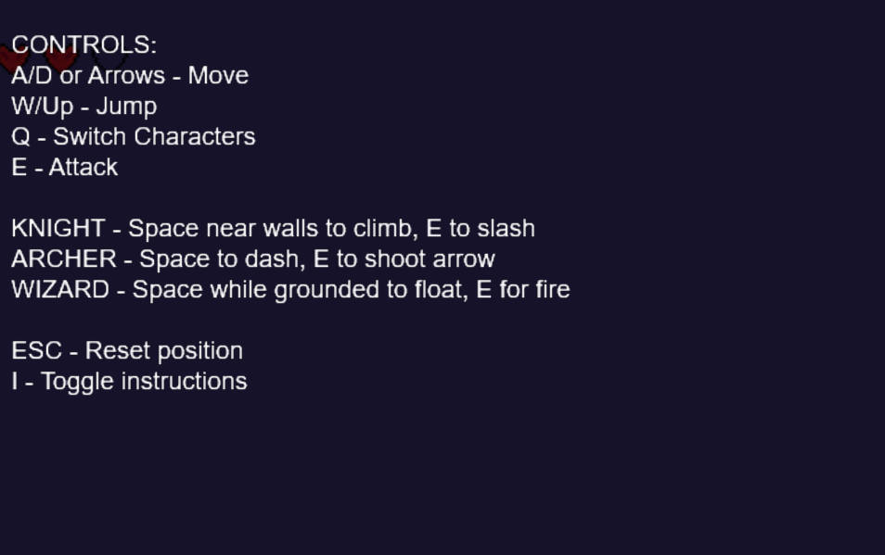

Direction Facing Movement

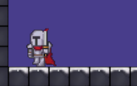

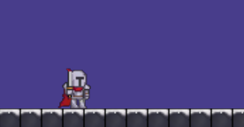

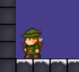

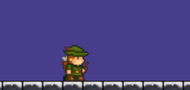

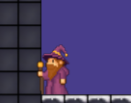

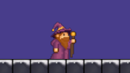

|  |  |  |
| --- | --- | --- |
| Feedback (Round 2) |  |  |
| Will yang | The aesthetic of the game is nice, the movement is nice, however some of the level may take too long maybe a save point would be cool, like a campfire. The dash may also be too long. |  |
| Timmy Li | A save point is probably needed. I like the aesthetic but maybe a few decorative brick types. You should be able to change to the character with number key instead of cycling with q |  |
| Logan Findlater | The other guys who are complaining about the difficulty are just haters, there is an obvious skill issue there. The 3 classes of character to switch through is a unique feature and allows for creative level design. The elf archer should dash the direction the player faces, not default to right unless moving left. The wizard is a bit bugged, going through walls. The knight worked well. |  |

Added Checkpoints, shortened and simplified the dash, set characters to number keys and made dashing based on direction faced instead of direction moving (with the default being right if idle)